# Employee Service Application

This SPA application performs CRUD operations of Employees. Application can search the employee by employee id which brings list size down. Application supports bulk employee creations in the form of excel import. The current employee list can be export to excel as well.

UI is designed on **Angular** framework with material design responsive screen. Server side is built on top of **spring boot** and backend is in **Mongodb**.

Following technologies stack being used:

* Spring Boot 1.5.7.
* Spring REST (MVC)
* Spring data MongoDB
* Apache-Poi 3.15
* Angular 4.0
* Angular-cli
* Material Design
* Maven 3.1
* JDK 1.8
* Typescript
* Eclipse MARS.1
* Tomcat
* Angular Webpack.

# Unit Test case results and Scenarios.

### 1.Landing page (Home)

* Employee list will be displayed in List with major details in landing page.
* Edit and delete icons in each row represents employee edit and delete respectively.
* File upload option helps to create bulk employees by importing excel format.
* File download option helps to export employee details in excel format
* Search by (EID) – options to search employee by ID.
* Create Icon/ Option helps to create new employee record.

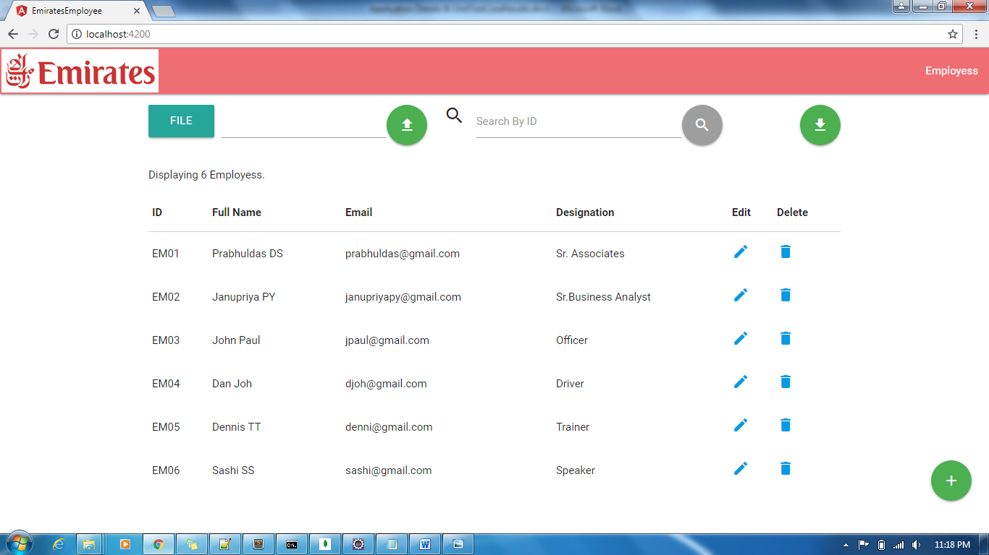

Landing page – File Upload

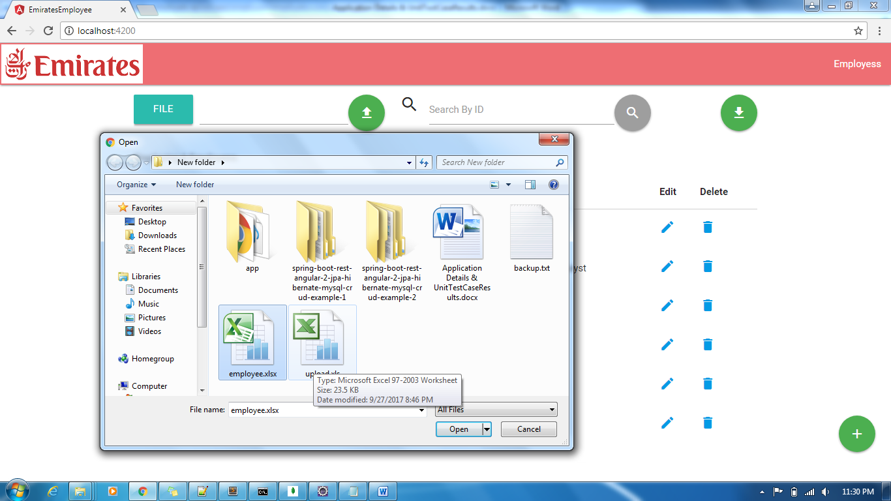

File is read for upload (.xls & .xlsx is alowed)

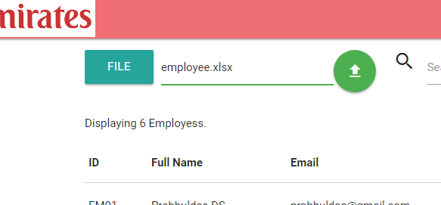

On click of Upload icon record will be saved.

Error message on wrong file selection for upload (.txt was selected).

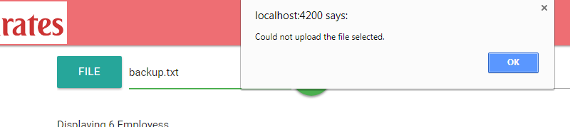

Search by ID – selection is EM02

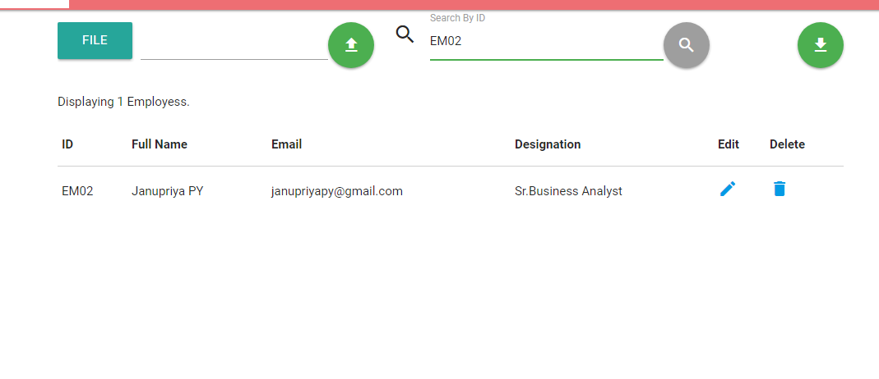

Search by no match condition

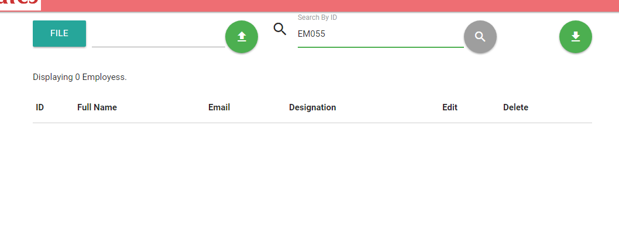

Download – on click of download, list will be downloaded in .xlsx format. Name is – employee.xlsx

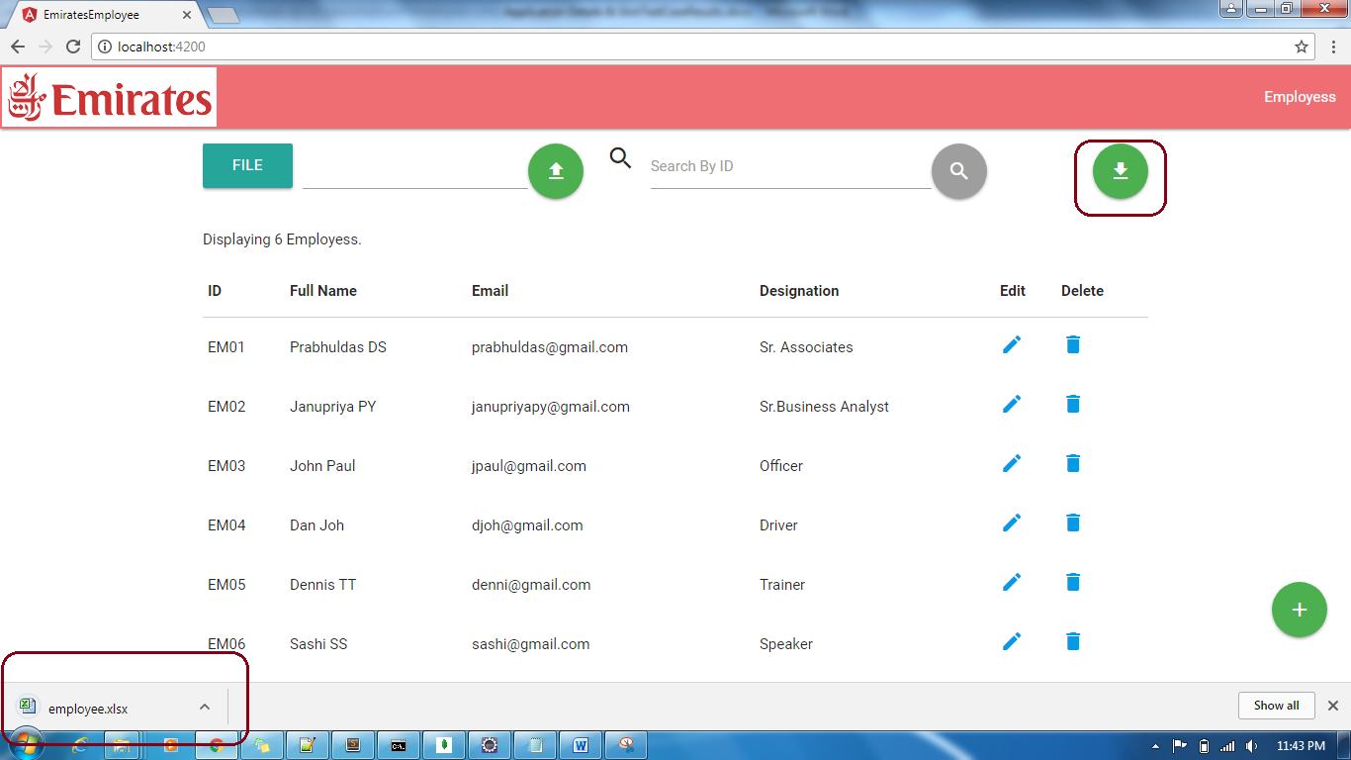

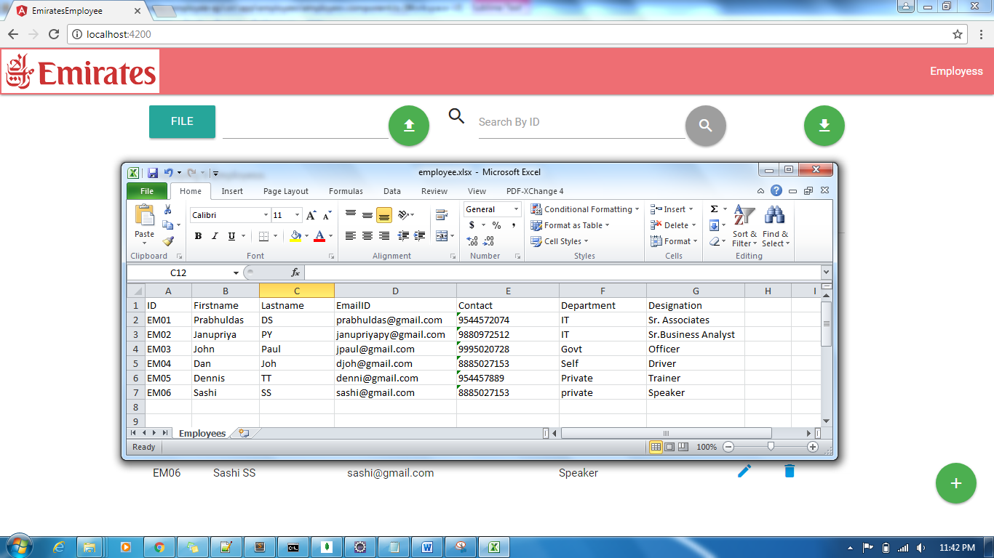

### 2. Create Page (Form)

* Required field validation and email validation are in place
* Form button will be enabled on proper data key in

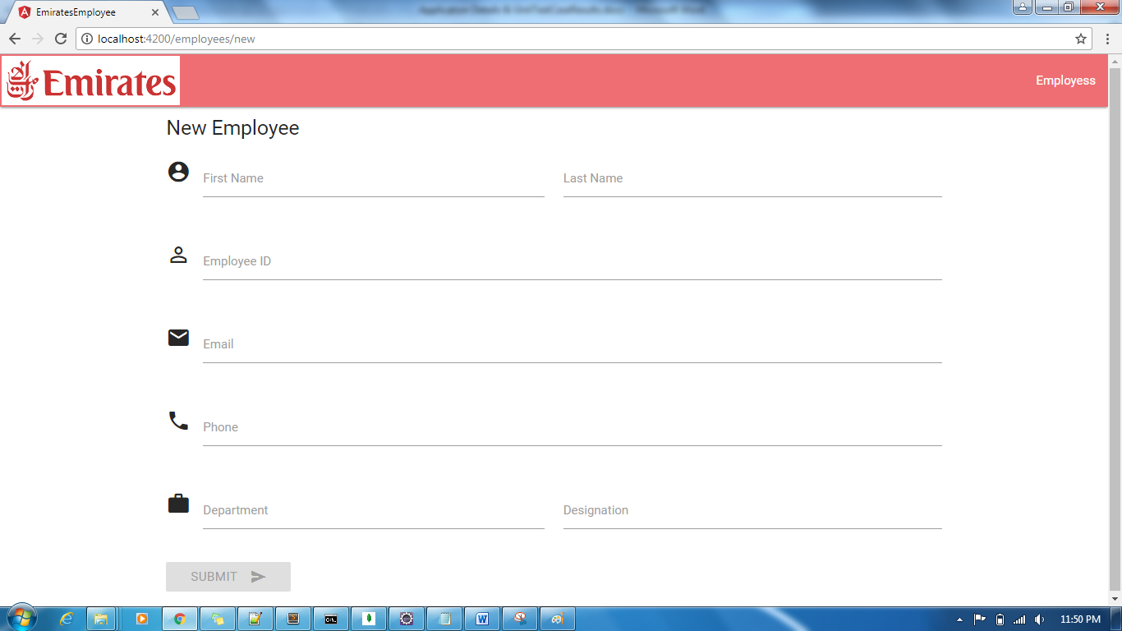

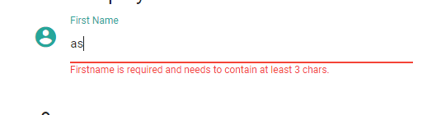

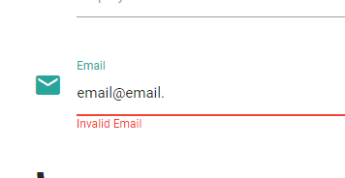

### 3. Edit Page

* On click of edit icon of a record in landing page, edit page gets loaded and populated with actual data from db.

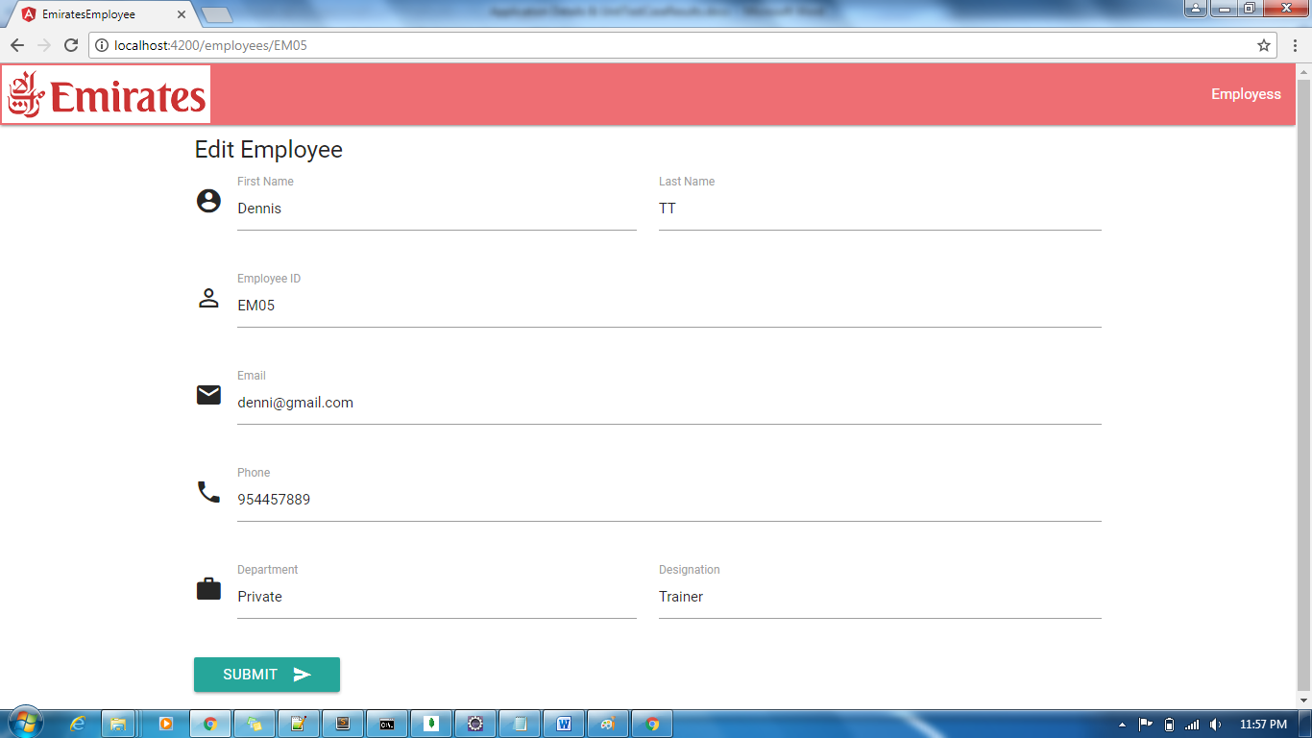

Updated designation and saved.

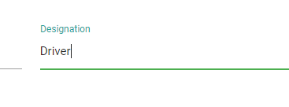

List is updated.



### 4. Delete

On click of delete icon of one record – EM06 - sashi.

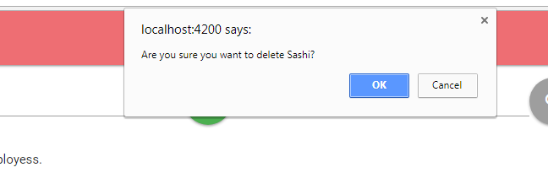

On click of ok confirmation, record will be deleted and list will be updated.

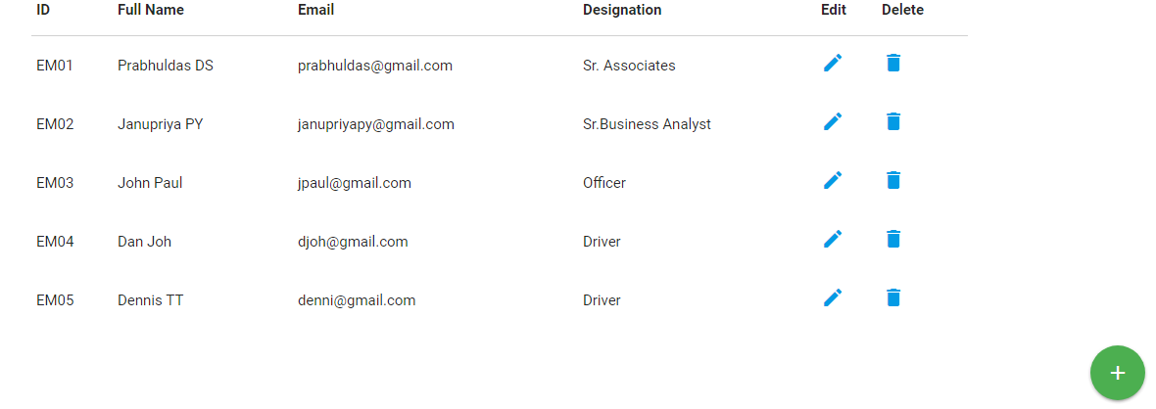

### Angular 4.0 Project Structure

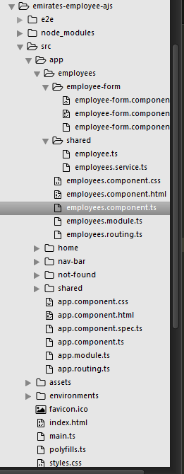

### Configuration – AJS

* Please set Server details at employee.service.ts file as per environment.

### Spring boot project structure

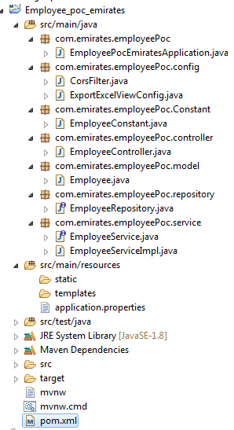

### Configuration – Spring Boot

* Please configure application.properties file as per environment
* Please use given template for data upload as to avoid xlsx’s text to number issue conflict with contact column.

`